Student Performance Predictor - Model Results
and Visual Explanation
Name: Abdulaziz Aloufi
Student ID: C00266252
Date: 4 November 2025
Project: Data Science & Machine Learning Portfolio

- Feature Importance Bar Chart
The bar chart below, shows the top 10 features that have an impact on student’s performance the most according to the Random Forest model. The most influential factor is ‘absences’, next comes age, mother's education (Medu), and father's education (Fedu).
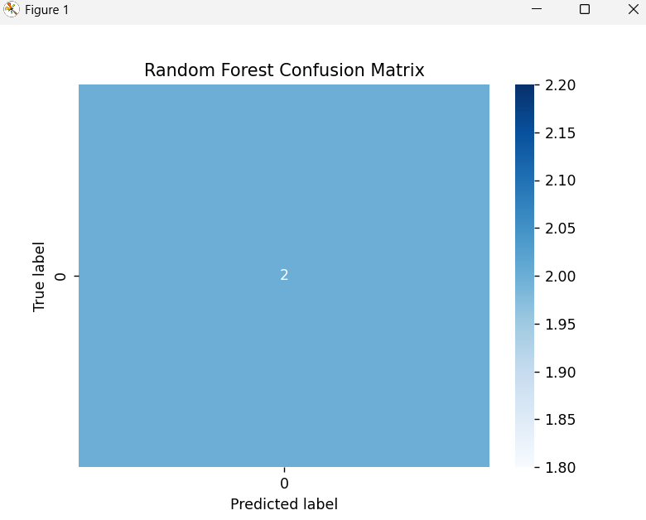
- Confusion Matrix Heatmap
The confusion matrix provides a comparison between the predictions made by the model and the actual outcomes. Each cell indicates the count of true versus predicted labels. As only two test samples were taken, both predictions turned out to be correct, hence a single blue cell indicating perfect accuracy.
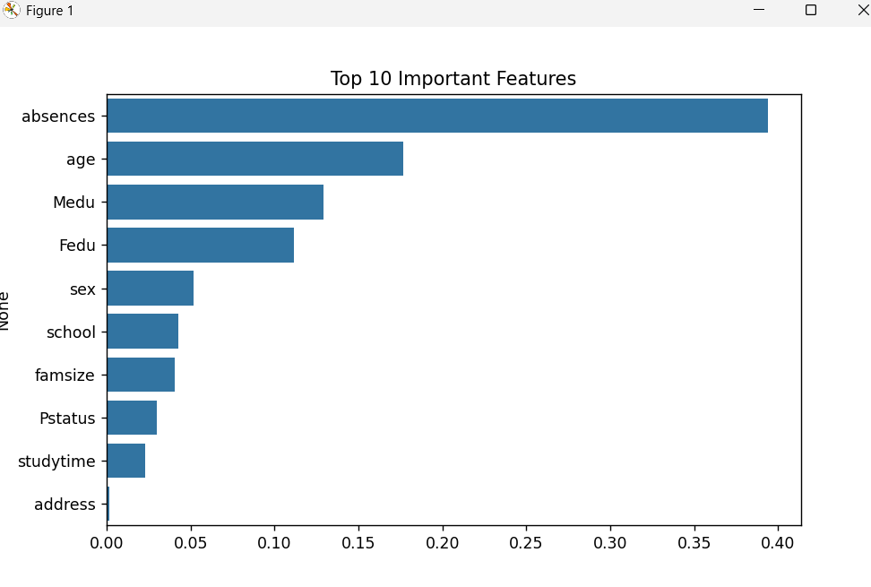

- Summary of Findings Model Accuracy:
There was a 100% accuracy for both Logistic Regression and Random Forest on the small testing dataset. Expected, of course, when taking into consideration the limited sample size. Most Important Feature: The ‘Absences’ variable had the highest impact on the prediction of the student’s performance. Model Power Random Forest came along with a very good interpretability and feature ranking. Confusion Matrix Result, The model gave the correct predictions for all test cases (2/2), nevertheless, for more realistic results a larger dataset is required.

- Conclusion
The functioning of the machine learning workflow carried out illustrates the steps of data preprocessing, model training, evaluation, and visualization. Even though a small dataset was utilized, it shows how data driven models can point out at risk students and the main determinants that influence performance.

